Login Page:

Register page:

New user page:

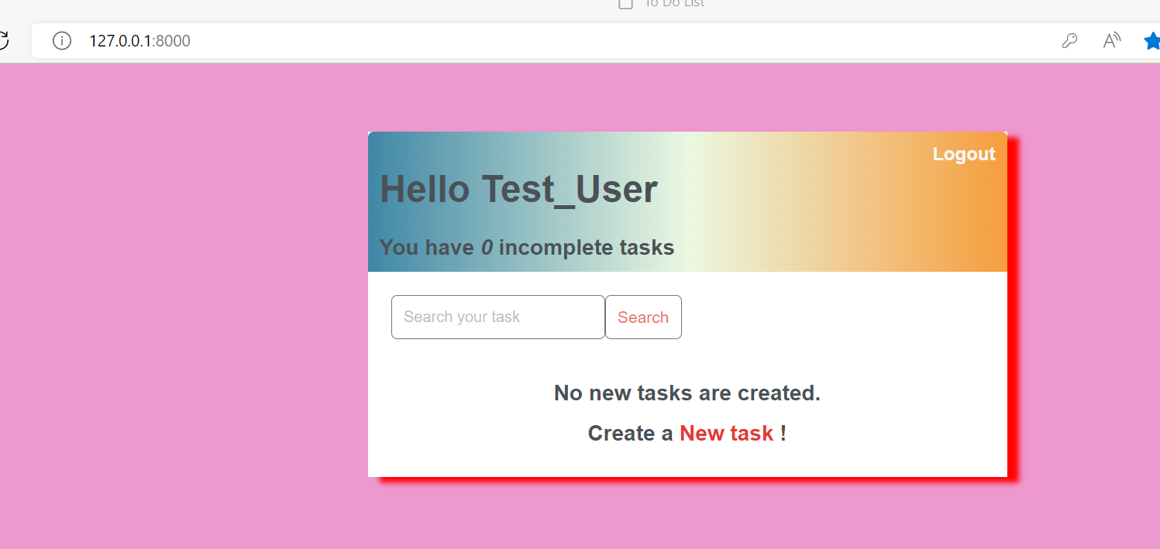

Task page :

Some tasks marked as complete

Admin login page:

Administrative page:

